**Here I am taking the same project for RUP as I did with Agile—**

**In RUP all the phases of project development are done in below mentioned steps and based on that the project is implemented, for better understanding few links attached.**

[**https://airbrake.io/blog/sdlc/rational-unified-process**](https://airbrake.io/blog/sdlc/rational-unified-process)

[**https://sea.ucar.edu/best-practices/rup**](https://sea.ucar.edu/best-practices/rup)

[**https://www.pmi.org/learning/library/project-management-rup-environment-8505**](https://www.pmi.org/learning/library/project-management-rup-environment-8505)

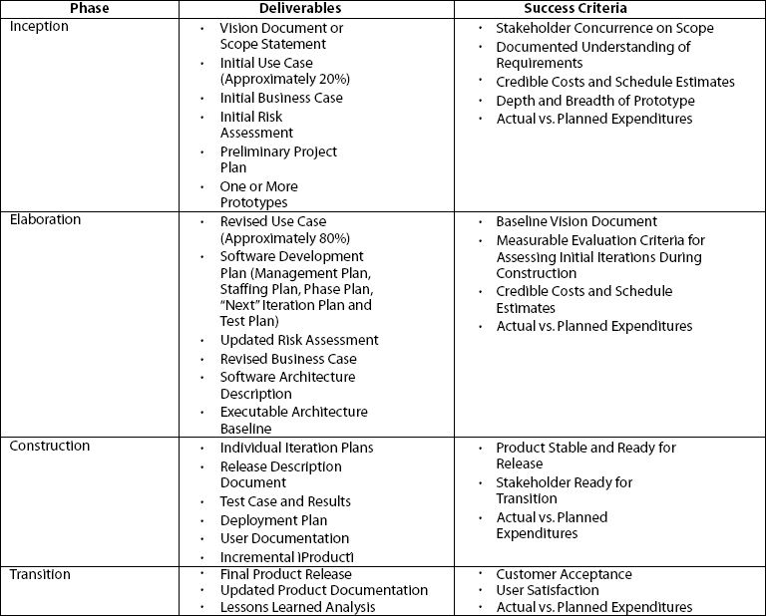

**Project description on RUP ---**

**Project Title:-Loan Management System**

**Here in this project the logic is for preparing a online system for loan application and as well as the payment system also.**

1. **Total time allotted is 4 month**
2. **Party involved consumer , manager**

**After the requirement gathering for first sprint i.e 14 days time line**

**Here the number of implemented requirement /services are mentioned below.**

|  |  |  |
| --- | --- | --- |
| **Module** | **Services** | **Entity** |
| **Consumer service** | **Online registration** | **consumer** |
| **Admin** | **Application verification** | **Manager** |

**Now here , we need to understand that there could be many requirements but we have decided to start with these two , we can consider them as most important .**

**RUP has below mentioned phases:--**

**On start we implement requirement analysis on them and implemented the BRD , overview document that includes feasibility study and other topics such as vision and mission documents .(Inception phase)**

**Then all the requirement is properly analyzed and various kind of SME is consulted as when to take some customized action on any requirement .**

**After that requirement are associated with there wireframe and user story**

**So all form of detailing can be implemented i.e FRD is prepared and technical team will analyses the report as is it possible to implement on time.(Elaboration phase)**

**After all this the actual project work is started and we prepare Testcase document RTM so all the technical team can implement the project on time.(Construction phase)(this phase is mainly for technical team)**

**At this end the project is ready and it will be delivered to actual user so we will provide UAT and any bug related report to technical team if needed.**

**(Transition phase )and at end the project will be deployed .**

**By the end of all this phase we must focus on timely delivery an here we can implement scrum framework on top of RUP as the project is divided into 4 month time .**

**Now after this , again on new requirement all the phases will be done to generate the project development or even if needed on fixing any issue in existing project services that we have taken care in above discussion all the phases can be re-done(Iteration phase)**